Created by Iceburg

Open up your Mario 64 Rom in HXD and paste the numbers corresponding to the Mario colors you want into address 0832B70

Ghost Mario

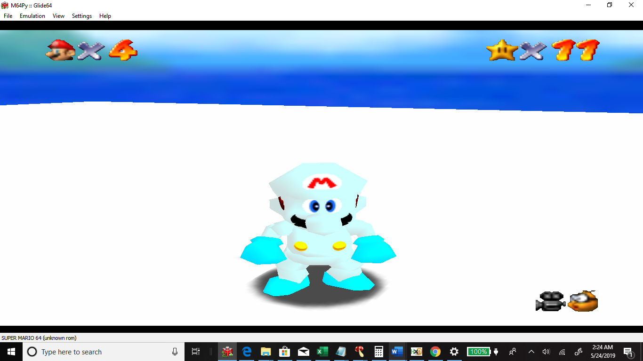

CD DE DE 00 30 00 7F 00 00 DD FF 00 00 00 FF FF 28 28 28 00 00 00 00 00 CD DE DE 00 7F 00 00 00 00 DD FF 00 FF 00 00 00 28 28 28 00 00 00 00 00 00 DD FF 00 10 10 10 00 00 51 FF 00 00 00 00 00 28 28 28 00 00 00 00 00 00 DD FF 00 39 0E 07 00 00 51 FF 00 72 1C 0E 00 28 28 28 00 00 00 00 00 CD DE DE 00 7F 60 3C 00 00 DD FF 00 FE C1 79 00 28 28 28 00 00 00 00 00 00 DD FF 00 39 03 00 00 00 51 FF 00 73 06 00 00 28 28 28 00

Doll/plastic Mario:

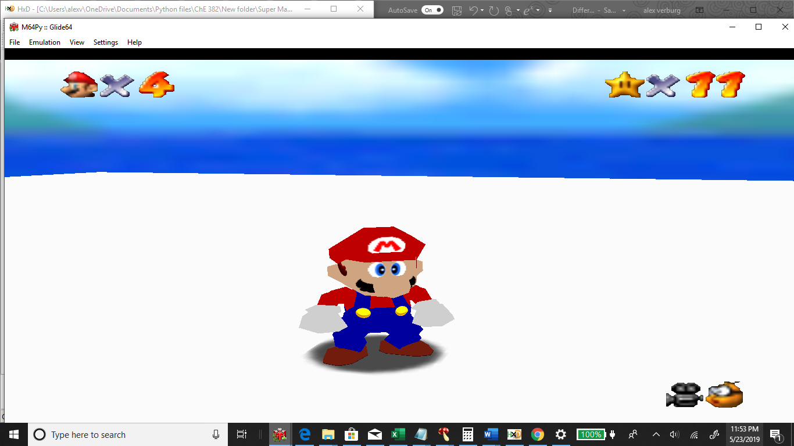

00 00 9F 00 00 00 7F 00 00 00 00 00 00 00 FF 00 00 00 00 00 00 00 00 00 BF 00 00 00 7F 00 00 00 00 00 00 00 FF 00 00 00 00 00 00 00 00 00 00 00 CF CF CF 00 7F 7F 7F 00 00 00 00 00 FF FF FF 00 00 00 00 00 00 00 00 00 72 1C 0E 00 39 0E 07 00 00 00 00 00 72 1C 0E 00 00 00 00 00 00 00 00 00 CF A5 81 00 7F 60 3C 00 00 00 00 00 FE C1 79 00 00 00 00 00 00 00 00 00 60 07 00 00 39 03 00 00 00 00 00 00 73 06 00 00 00 00 00 00

Bloodthirsty Mario

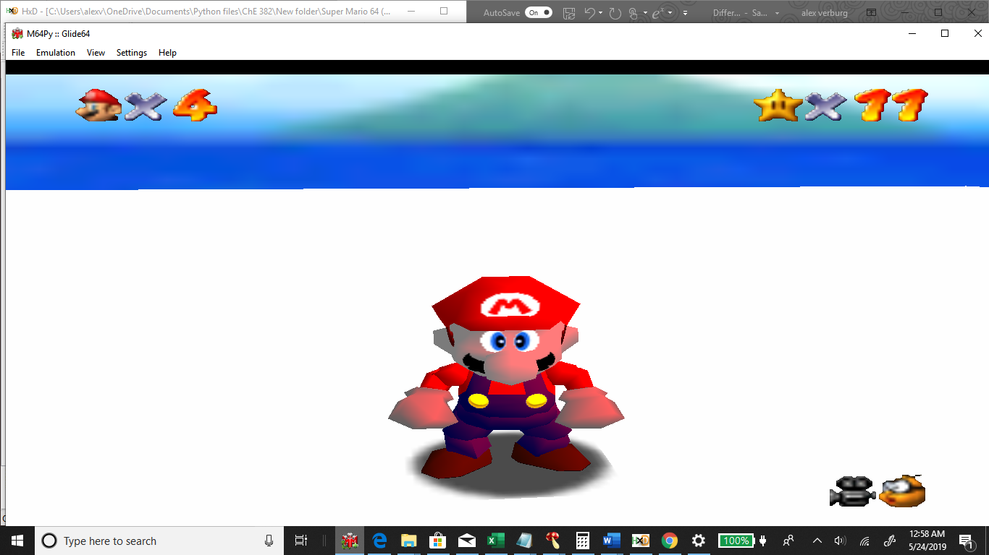

00 00 44 00 00 00 7F 00 88 00 00 00 00 00 FF 00 28 28 28 00 00 00 00 00 7F 00 00 00 7F 00 00 00 FF 00 00 00 FF 00 00 00 28 28 28 00 00 00 00 00 5F 5F 5F 00 7F 7F 7F 00 FF 00 00 00 FF FF FF 00 28 28 28 00 00 00 00 00 26 06 00 00 39 0E 07 00 50 02 00 00 72 1C 0E 00 28 28 28 00 00 00 00 00 7B 7B 7B 00 7F 60 3C 00 FF 00 00 00 FE C1 79 00 28 28 28 00 00 00 00 00 39 03 00 00 39 03 00 00 73 06 00 00 73 06 00 00 28 28 28 00

Halloween (Black and orange)

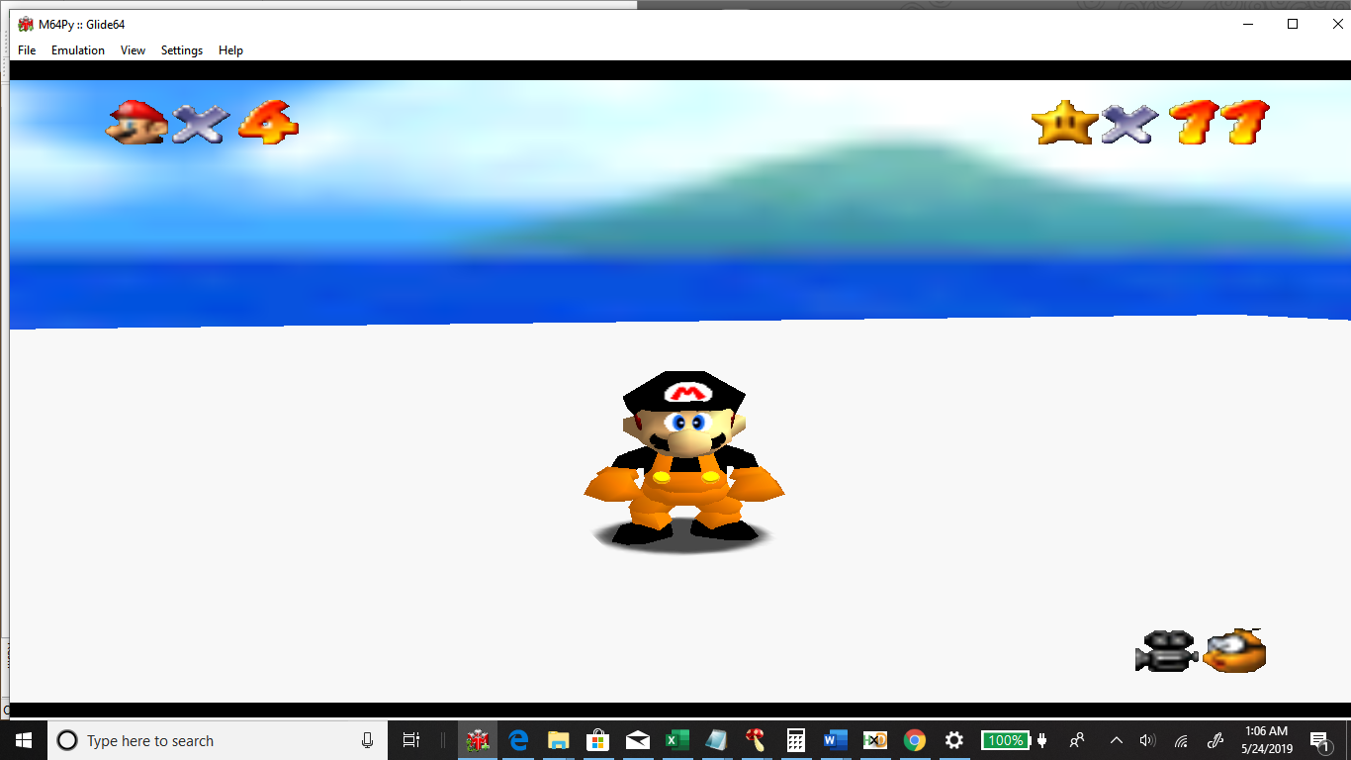

B3 59 00 00 00 00 7F 00 7D 3E 00 00 00 00 FF 00 28 28 28 00 00 00 00 00 00 00 00 00 7F 00 00 00 00 00 00 00 FF 00 00 00 28 28 28 00 00 00 00 00 B3 59 00 00 7F 7F 7F 00 7D 3E 00 00 FF FF FF 00 28 28 28 00 00 00 00 00 00 00 00 00 39 0E 07 00 00 00 00 00 72 1C 0E 00 28 28 28 00 00 00 00 00 7F 60 3C 00 7F 60 3C 00 FE C1 79 00 FE C1 79 00 28 28 28 00 00 00 00 00 39 03 00 00 39 03 00 00 73 06 00 00 73 06 00 00 28 28 28 00

Green goblin Mario

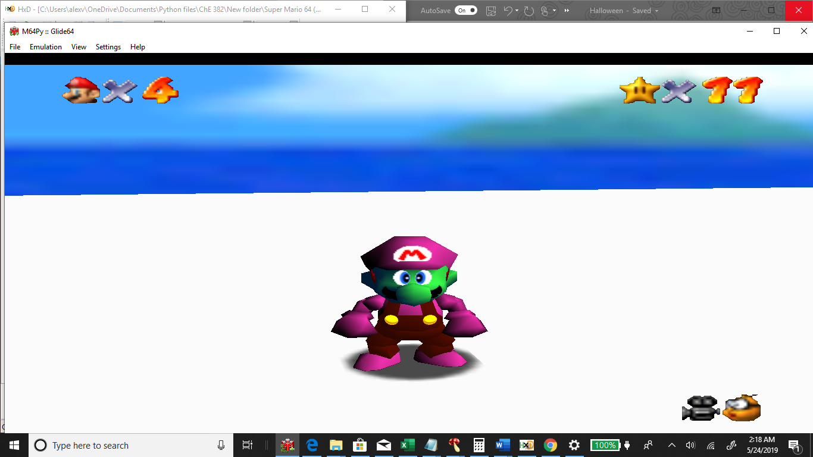

2B 07 00 00 30 00 7F 00 33 08 00 00 00 00 FF FF 28 28 28 00 00 00 00 00 00 00 00 00 7F 00 00 00 FF 34 B8 00 FF 00 00 00 28 28 28 00 00 00 00 00 00 00 00 00 10 10 10 00 FF 34 B8 00 00 00 00 00 28 28 28 00 00 00 00 00 00 00 00 00 39 0E 07 00 FF 34 B8 00 72 1C 0E 00 28 28 28 00 00 00 00 00 00 1A 33 00 7F 60 3C 00 40 FF 19 00 FE C1 79 00 28 28 28 00 00 00 00 00 39 03 00 00 39 03 00 00 73 06 00 00 73 06 00 00 28 28 28 00